# Final project documentation

Title of webpage: The food blog

## Front-end

For the Front-end part of the project the following item will be included in the project and the page that will be included in the project will the homepage, individual page, Categories, About us, Contact us. All of the pages will have the following div in common:

**Top-navbar:** In the top nav bar of the project, left side with consist of logo and name of the webpage and on the right side of the nav-bar login and register button for the project will be included.

**Menu-bar**: menu bar will consist of following item in the left side:

1. Home
2. Categories
3. Health
4. Contacts
5. About us

And on the right side of the menu bar a search bar will be implemented.

**Footer**

Basic footer saying copyright and social links

## Homepage

In the homepage navbar, menu bar is located at the top and footer is located in the button. As for the main home screen at the very beginning we have a hero section

**Hero-section** will consist of slider that slide to different blog section of the page with 3-4 slider.

After the hero-section we have the **trending section** in the trending section of this website there will be two sections, left and right section. Left section will consist of editor’s and right section will consist of trending blog for the website some like the picture given below:

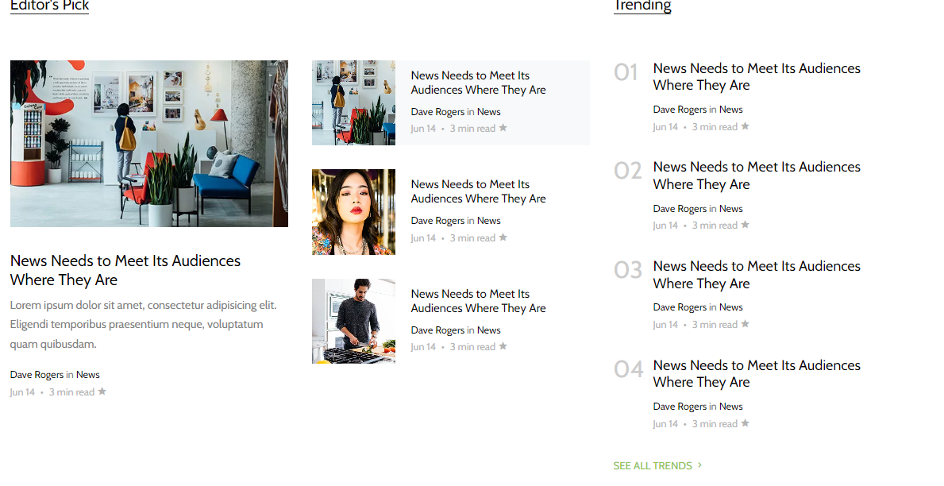

## Categories

For this page there will be icon name of the categories while clicking over the link it will redirect to the respective categories and show the list of blogs. Something like the image below:

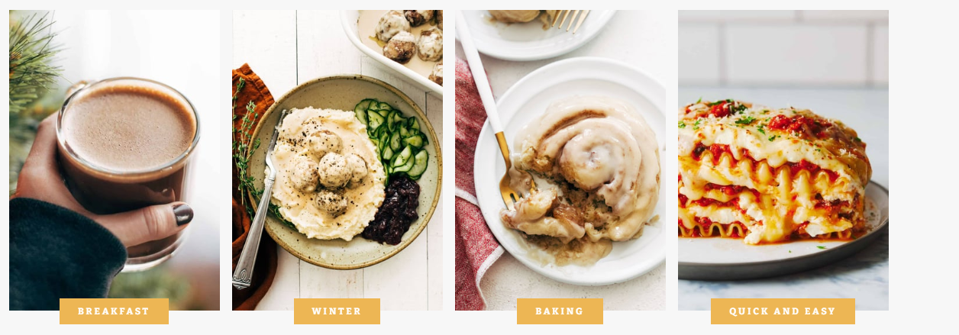

## About us

This page will consist of description of the page and what it is about which is dynamic and will be directed from database

## Contact us

This page will consist of a form that submits does the mailing directly to me personal email which will look something like the image below:

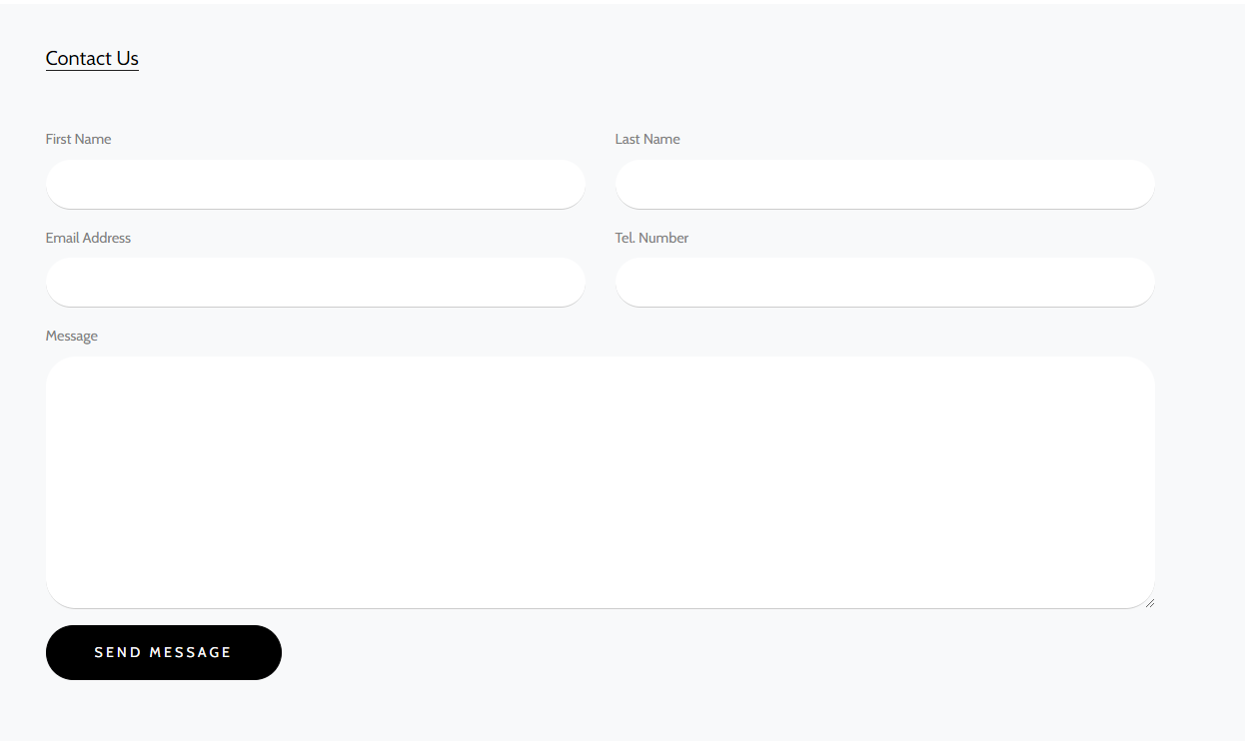

## Individual blog page

The individual blog page will have one main section that is divided into two sections:

On the left section that covers 70% of the page will have image and editors name written and description written in below and in the right side of the section will have the trending list as used in the main homepage so users can navigate easily. Something like the image below:

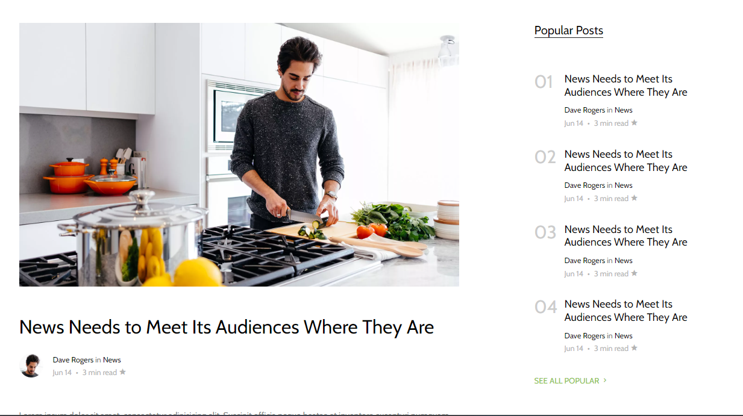

# Back-end

In the back-end part we will have admin panel page that will add the menu, footer, navbar content dynamically. Which will consist of contain something like the nice admin given below:

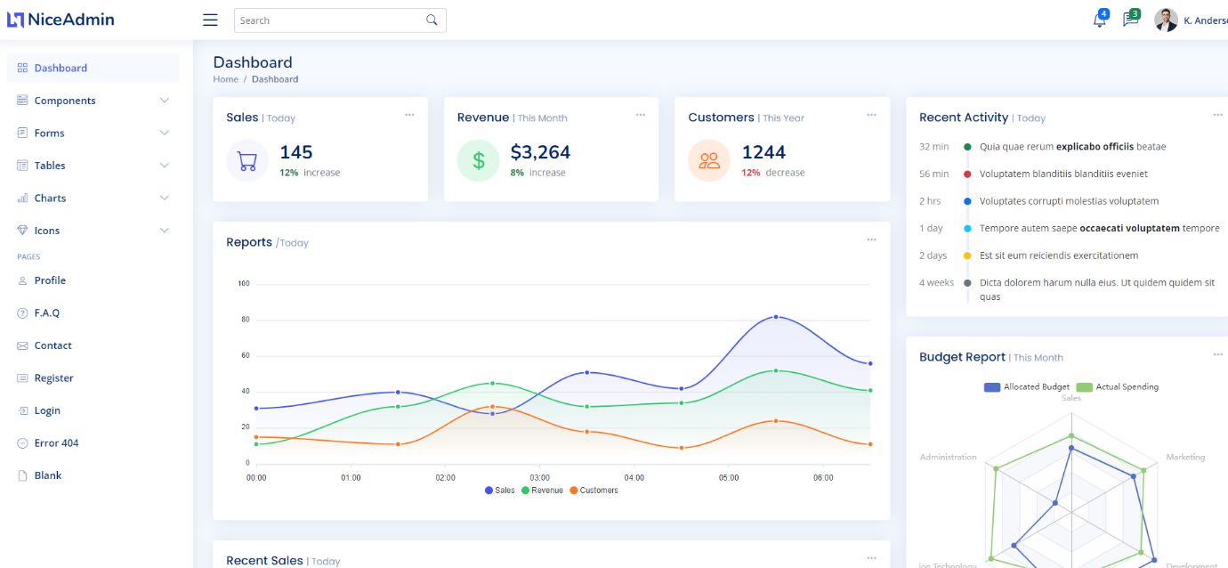

As for the **database** part, we will have the following tables and entity and I have created a demo ERD for the database:

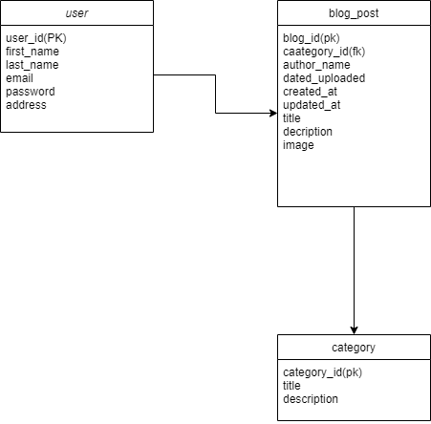

There will be an additional page with user profile in which they are able to add blog related to the respective field where they can insert image and description and the date that is able will be available from real time.